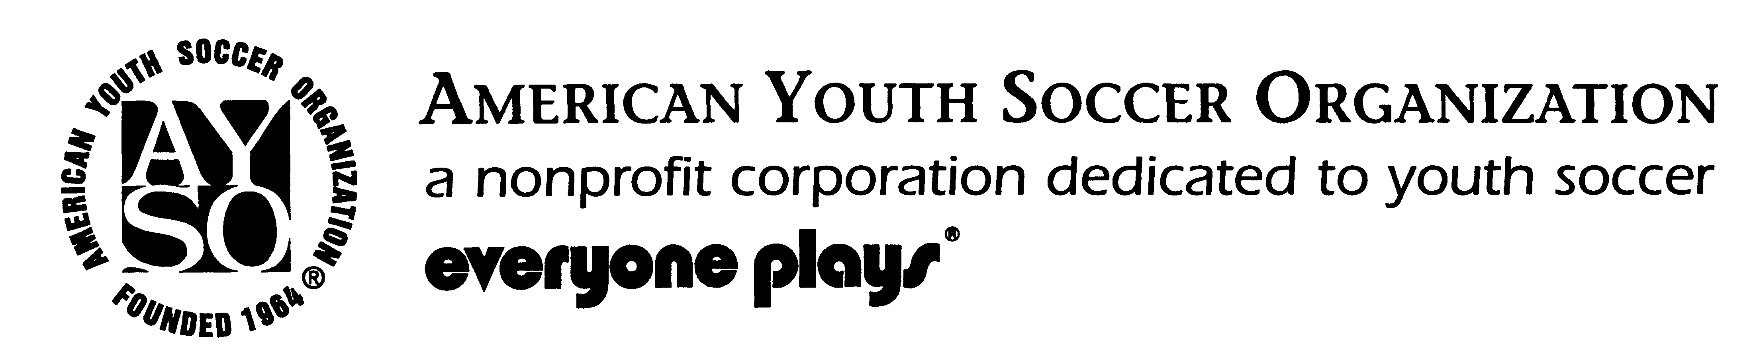
AYSO Area 5I - East Tennessee
Region 335 Includes:
Hamblen, Jefferson & Grainger
THE SIX AYSO PHILOSOPHIES

- OPEN REGISTRATION
- EVERYONE PLAYS
(at least ½ of the game)
- POSITIVE COACHING
- BALANCED TEAMS
- GOOD SPORTSMANSHIP
- PLAYER DEVELOPMENT

Have a question about a date, time, or place? Need a phone number? Will games be played?

Check out our web site: www.ayso335.org

Welcome to the Fall 2023 season we look forward to working with all the volunteers, parents, and children to make this spring a great season.
We have a great region. Currently we have 500 to 600 children participating on approximately 70 teams each season, beautiful playing fields, and a good group of volunteers.
We are a growing region. We need volunteers as coaches and referees so we can continue to provide a high-quality soccer experience. Please donate some of your time to help create a fun and safe atmosphere for the children of our region. Check with the coach, referee administrator, or myself for opportunities.
Eric Wright,
Regional Commissioner

Fall 2023 CALENDAR

Fall Registration Dates:
Online Registration Starting
July 1, 2023- August 1, 2023

Coaches Meeting:
Monday, August 7 at 6:00 pm. at Gateway Church

Spring Season:

Practices start Monday, August 14, 2023
Games start Saturday, September 9, 2023
Season ends Saturday, October 28, 2023.

Registration Costs

$1st child $50.00
2nd child in same immediate family $45.00
3rd child & all additional children in same immediate family $40.00

Late Registrations become part of a waiting list and there is no guarantee your child will be placed on a team. Late fees may apply!

Important Region 335 Contacts

Regional Commissioner:

Eric Wright – (423) 736-1466, eswright2@yahoo.com
Registrars:
Abe Walker – (423) 254-0335
Treasurer:

Jeanine Bane – (423) 312-9352
Referee Administrator:
Paul Owens- (865) 850-3743
Assist Ref Administrator
Adam Cooper- (423) 312-8030
Coach Administrator:

Scott Carr – (423) 736-9331
Safety Director:

Joe Bane, Safety Director – (423) 748-4469
Child-Volunteer Protection Advocate:
Rita Wright, CVPA – (423) 748-3047
Purchasing Director:
Abe Walker – (423) 254-0335
DIVISION COORDINATORS:
U-6 Jermiah Wilder - (423) 312-0569

U-8 Gary Hughes – (865) 973-6256
U-10 Chris Knight – (865) 206-4036
U-12 Scott Carr – (423) 736-9331
U-14-Crystal Pace- (865) 585-7404
U-16/19- Gary Hughes- (865) 973-6256

Practice Scheduler
Joe Frye - (423)587-2942

All Emails for contacts can be found at

www.ayso335.org/contacts

U6 & U8 Divisions

red/yellow jerseys, size 3 ball, 6 players on field, 20-minute halves, U6 games on Saturdays, U8 games on Saturdays

U10 Division

green/white jerseys, size 4 ball, 7 players on field, 25-minute halves, games on Saturdays

U12 Division
green/white jerseys, size 4 ball, 9 players on field, 30-minute halves, games on Saturdays

U14 Division

blue/white jerseys, size 5 ball, 11 players on field, 35-minute halves, games on Saturdays

U16/U19 Divisions

blue/white jerseys, size 5 ball, 11 players on field, 40-minute halves for U16, 45-minute halves for U19, games on Saturdays, some “away,” or inter-regional, games

Jerseys

$30.00 a set- comes with 2 colors (home/away)

OTHER DATES

-East Tennessee Autumn Classic- November 4-5, 2023, Morristown.
- Referee training, Saturday, August 26, 2023, Gateway Church

